**Depression Screening Report**

1. **Introduction:**

Despite being a vital component of total wellbeing, mental health is frequently disregarded or misinterpreted in our culture. Millions of people worldwide are impacted by the common and dangerous mental health illness known as depression in particular. Despite its pervasive effects, stigma, ignorance, or lack of resources make it difficult for many people to identify the symptoms and seek assistance.

In response to the urgent need for easily accessible and efficient instruments for mental health evaluation, the Depression Screening Project was created. By utilising contemporary technology, this project seeks to democratise mental health screening by offering a comprehensive and user-friendly platform that allows anyone to assess their mental health from the comfort and privacy of their own homes.

At the heart of the Depression Screening Project lies a multifaceted approach to screening that incorporates elements of both traditional questionnaire-based assessments and cutting-edge technology-driven methods. By combining these approaches, the project seeks to capture a holistic picture of the user's mental health, taking into account not only their self-reported symptoms but also subtle cues conveyed through facial expressions and speech patterns.

The project is built upon a foundation of advanced software engineering, with the frontend interface developed using ReactJS to ensure a seamless and intuitive user experience. Meanwhile, the backend infrastructure, powered by Python Flask, provides the necessary APIs for data processing, analysis, and reporting.

The registration process and basic information input are the first of several thoughtfully crafted processes that make up the screening process. Users are then led through a series of tests that focus on various aspects of mental health. The questionnaire test probes the user's ideas, emotions, and actions and acts as a preliminary evaluation. Simultaneously, advanced algorithms are employed to analyse and recognise tiny emotional indicators in facial photographs.

Users are invited to take part in tests of voice and facial emotion recognition after completing the questionnaire. These tests use artificial intelligence and machine learning to analyse speech patterns and facial expressions, respectively, to provide deeper insights into the user's emotional state.

Upon completion of all tests, the collected data is transmitted to the backend, where it undergoes thorough analysis using specialized algorithms tailored to each test type. These algorithms draw upon extensive research and training data to interpret the user's responses and predict their mood with a high degree of accuracy.

The ultimate goal of the Depression Screening Project is twofold: to raise awareness about depression and other mental health conditions, and to empower individuals to take proactive steps towards self-care and treatment. By providing users with personalized reports that highlight potential areas of concern and offer resources for support and intervention, the project aims to facilitate early detection and intervention, ultimately improving outcomes for those affected by depression.

The Depression Screening Project is an innovative endeavour aimed at utilising technology to improve mental health. The project aims to significantly improve the lives of people who are depressed by fusing cutting-edge screening techniques with user-centric design concepts. This will help to create a supportive, understanding, and empathic culture.

1. **Problem Statement:**

Despite the growing recognition of mental health as a critical component of overall well-being, there persists a significant gap in the timely detection and treatment of mental health conditions, particularly depression. This gap is fueled by various factors, including stigma, lack of awareness, and limited access to resources. As a result, millions of individuals around the world continue to suffer silently, with their mental health needs often going unmet.

The absence of easily available and reliable screening instruments is one of the main obstacles in treating the problem of depression. Conventional approaches of mental health assessment, like in-person assessments by medical professionals, are frequently expensive, time-consuming, and vulnerable to a number of obstacles, such as social stigma, geographic isolation, and financial limitations.

Furthermore, although questionnaire-based tests are frequently employed as a preliminary step in the screening process for depression, their ability to capture the entire range of symptoms is limited, and self-report biases and mistakes may be present. Furthermore, these evaluations frequently miss the minute details of emotional expression that might reveal important information about a person's mental health.

Moreover, existing digital screening tools often lack the sophistication and comprehensiveness needed to provide meaningful insights into an individual's mental health. Many of these tools rely solely on self-reported data and lack the capability to integrate multiple data sources or leverage advanced technologies such as machine learning and artificial intelligence for more accurate assessment.

Given these difficulties, there is an urgent need for creative and user-friendly screening instruments that can close the gap between those in need of mental health assistance and the resources at their disposal. These instruments ought to be easy to use, reasonably priced, and able to record both objective measures of emotional well-being and self-reported symptoms to provide a comprehensive picture of a person's mental health condition.

The Depression Screening Project aims to address these issues by giving people access to an extensive and cutting-edge platform for evaluating their mental health. The project attempts to give a more accurate and comprehensive screening experience by fusing components of conventional questionnaire-based assessments with state-of-the-art face and speech emotion recognition technologies.

Through the development of this project, we aim to not only raise awareness about depression and other mental health conditions but also empower individuals to take proactive steps towards self-care and treatment. By providing accessible and effective screening tools, we hope to contribute to the early detection and intervention of depression, ultimately improving outcomes and quality of life for those affected by this pervasive mental health condition.

1. **Hardware and Software Requirements:**

The successful implementation of any computational project hinges not only on the ingenuity of the algorithms and methodologies employed but also on the robustness and efficiency of the hardware and software infrastructure supporting them. In this section, we outline the specific hardware and software requirements essential for the execution of the project, ensuring optimal performance, scalability, and compatibility.

**3.1 Hardware Requirements**

The hardware requirements for this project are contingent upon the computational complexity of the algorithms utilized, the size of the dataset under consideration, and the desired speed and efficiency of execution. While the project can be implemented on a range of hardware configurations, including personal computers and servers, the following specifications are recommended for optimal performance:

**3.1.1 Central Processing Unit (CPU)**

* Type: Multi-core processor (e.g., Intel Core i7 or AMD Ryzen 7)
* Speed: 2.5 GHz or higher
* Cores/Threads: Quad-core or higher (with support for multi-threading)
* Cache: L3 cache of 8 MB or more

**3.1.2 Graphics Processing Unit (GPU)**

* Type: NVIDIA GeForce GTX or Quadro series (for CUDA-based acceleration)
* CUDA Cores: Minimum 512 CUDA cores
* Memory: 4 GB GDDR5 or higher
* CUDA Toolkit: NVIDIA CUDA Toolkit

**3.1.3 Random Access Memory (RAM)**

* Capacity: 16 GB DDR4 RAM (or higher)
* Speed: 2400 MHz or faster
* Configuration: Dual-channel configuration for improved memory bandwidth

**3.1.4 Storage**

* Primary Storage: Solid State Drive (SSD) for faster data access and application loading
* Capacity: 512 GB or more for storing datasets, models, and software tools
* Secondary Storage: Hard Disk Drive (HDD) for archival and backup purposes
* Capacity: 1 TB or more

**3.2 Software Requirements**

The software requirements encompass the essential tools, libraries, frameworks, and development environments necessary for developing, testing, and deploying the project components. While some software dependencies are inherent to the chosen programming languages and frameworks, others are specific to the algorithms and methodologies employed. The following software components are integral to the project:

**3.2.1 Programming Languages**

* Python: Version 3.7 or later
* R: Version 4.0 or later (if applicable)

**3.2.2 Integrated Development Environments (IDEs)**

* PyCharm, Spyder, or Jupyter/ Colab Notebook: For Python-based development

**3.2.3 Libraries and Frameworks**

* TensorFlow: For deep learning model development and training
* Keras: High-level neural networks API (compatible with TensorFlow)
* PyTorch: Alternative deep learning framework
* Scikit-learn: For machine learning algorithms and tools
* NumPy, Pandas, Matplotlib: Fundamental libraries for data manipulation and visualization
* OpenCV: For computer vision tasks
* CUDA Toolkit: NVIDIA CUDA Toolkit for GPU acceleration

**3.2.4 Version Control**

* Git: Version control system for managing project source code and collaboration

1. **Flowchart:**

A flowchart serves as a visual representation of the sequential steps and decision points within a process or algorithm. In the context of this project, the flowchart illustrates the logical flow of operations involved in the execution of the proposed solution, guiding developers and stakeholders through the intricacies of the system architecture and workflow. Below, we provide a detailed description of the flowchart components, outlining each step and decision node to elucidate the project's operational dynamics.

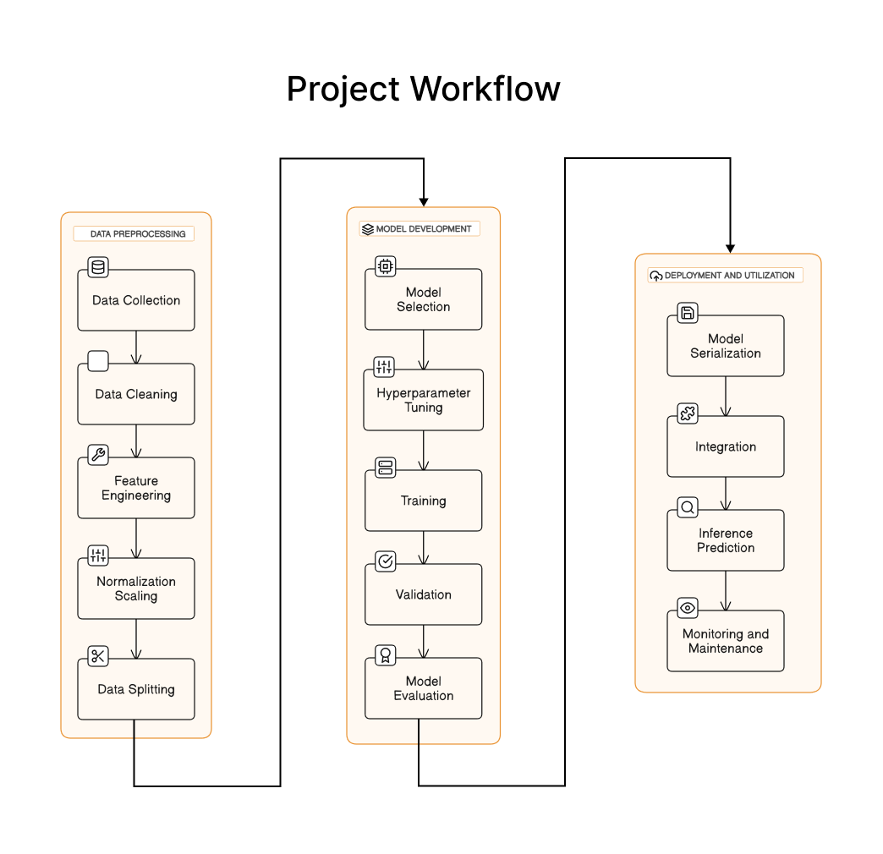

Fig. Project Workflow

**4.1 Overview of the Flowchart**

The flowchart outlines the whole project workflow, from data preprocessing through model training and assessment to deployment and application of the trained model for tasks involving inference or prediction. With branching routes to accommodate different conditions and contingencies that may develop during execution, every step of the process is painstakingly preserved.

**4.2 Detailed Description of Flowchart Components**

**4.2.1 Data Preprocessing**

The initial phase of the flowchart encompasses data preprocessing tasks aimed at cleansing, transforming, and augmenting the raw input data to make it suitable for model training. This stage involves the following steps:

* Data Collection: Acquire raw data from diverse sources, such as databases, APIs, or files.
* Data Cleaning: Identify and rectify missing values, outliers, and inconsistencies in the dataset.
* Feature Engineering: Extract relevant features from the raw data and encode categorical variables.
* Normalization/Scaling: Standardize numerical features to a common scale to facilitate convergence during training.
* Data Splitting: Partition the dataset into training, validation, and testing sets for model evaluation.

**4.2.2 Model Development**

Once the data preprocessing phase is completed, the flowchart transitions to the model development stage, where various machine learning or deep learning architectures are constructed and trained using the preprocessed data. This stage involves the following steps:

* Model Selection: Choose an appropriate machine learning algorithm or neural network architecture based on the nature of the problem (e.g., classification, regression).
* Hyperparameter Tuning: Optimize model hyperparameters using techniques such as grid search or random search to enhance performance.
* Training: Train the selected model using the training dataset, iteratively adjusting weights and biases to minimize the loss function.
* Validation: Validate the trained model's performance using the validation dataset to prevent overfitting and assess generalization capability.
* Model Evaluation: Evaluate the model's performance metrics, such as accuracy, precision, recall, and F1 score, on the testing dataset.

**4.2.3 Deployment and Utilization**

Upon successful training and evaluation of the model, the flowchart proceeds to the deployment and utilization phase, where the trained model is deployed in a production environment for real-world inference or prediction tasks. This stage involves the following steps:

* Model Serialization: Serialize the trained model to a file format compatible with deployment frameworks (e.g., TensorFlow SavedModel, ONNX).
* Integration: Integrate the serialized model into the target application or system architecture, ensuring compatibility and scalability.
* Inference/Prediction: Utilize the deployed model to make predictions or perform inference on new, unseen data in real-time or batch processing scenarios.
* Monitoring and Maintenance: Continuously monitor the deployed model's performance and conduct periodic maintenance to address drift, degradation, or evolving requirements.

**4.3 Benefits of Using a Flowchart**

The utilization of a flowchart offers several benefits throughout the project lifecycle, including:

* Clarity and Understanding: Provides a clear and concise visualization of the project workflow, facilitating comprehension for developers and stakeholders.
* Error Identification: Enables early detection of potential errors, bottlenecks, or inefficiencies within the system architecture, leading to preemptive remediation.
* Documentation: Serves as a comprehensive documentation artifact, aiding in knowledge transfer, onboarding, and future reference.
* Communication: Facilitates effective communication and collaboration among team members by delineating roles, responsibilities, and dependencies.

1. **Working:**

There are following steps involved in working of project:

**5.1 Data Ingestion and Preprocessing:**

The operational mechanism starts when unprocessed data is fed in from various databases, repositories, or streaming sources. Before being used for downstream analysis and model training, this raw data is cleaned, transformed, and normalized by a number of preparation procedures. Tasks like data cleaning, feature extraction, and normalization are all part of the preprocessing pipeline, which makes sure that the input data is standardized and free of biases or inconsistencies that could affect the performance of the model.

**5.2 Model Training and Evaluation:**

Following data preprocessing, the project transitions into the model training and evaluation phase, wherein machine learning or deep learning models are constructed and trained using the preprocessed data. This stage involves the selection of an appropriate model architecture, optimization of hyperparameters, and iterative training using gradient-based optimization techniques. The trained models are then evaluated using validation datasets to assess their performance metrics, such as accuracy, precision, recall, and F1 score, thereby enabling the selection of the most suitable model for deployment.

**5.3 Model Deployment and Utilization:**

The project moves on to the deployment and utilization phase when training and evaluation are completed successfully. During this phase, the trained models are used for real-world inference or prediction tasks in a production setting. During this stage, trained models are serialized as deployable artifacts, integrated into target applications or systems, and inference pipelines are set up to enable batch or real-time processing of incoming data. Decision-making processes can be automated and useful insights can be produced by using the deployed models' learnt parameters to do inference or make predictions on previously unknown data.

**5.4 Monitoring and Maintenance:**

Apart from the fundamental functional procedures, the project integrates systems for oversight and upkeep to guarantee the sustained effectiveness and dependability of the implemented models. It is possible to identify abnormalities or departures from expected behavior in a timely manner by continuously monitoring model performance metrics, data drift, and system health. This allows for the necessary retraining of the model or the implementation of corrective steps. Regular maintenance tasks, like adding feedback loops, resolving idea drift, and changing model weights, keep the deployed models accurate and relevant over time, increasing their usefulness and endurance in practical applications.

**5.5 Integration with External Systems:**

In order to promote interoperability and data interchange, the project also requires smooth interface with external systems, APIs, or platforms. Collaboration and improved operational efficiency are fostered by the smooth flow of information across various components made possible by integration with data sources, visualization tools, or business systems. The project promotes the adoption of data-driven decision-making paradigms across organizational boundaries and fosters synergy with existing infrastructure by providing robust integration frameworks and standardized interfaces.

**5.6 Scalability and Performance Optimization:**

Lastly, the project emphasizes scalability and performance optimization to accommodate growing data volumes, user demands, and evolving business requirements. Through the adoption of scalable architectures, distributed computing frameworks, and parallel processing techniques, the solution exhibits resilience and elasticity in the face of fluctuating workloads and resource constraints. Additionally, continuous optimization efforts, such as algorithmic refinements, parallelization, and hardware acceleration, enhance the system's efficiency and responsiveness, ensuring that it can deliver timely insights and predictions even under challenging conditions.

1. **Results & Discussions:**

**1. PHQ9 Test Model:**

The RandomForestClassifier model emerged as the most promising solution for the questionnaire-based assessment. After thorough experimentation and hyperparameter tuning, the model achieved exceptional accuracy, precision, recall, and F1-score, all exceeding 99%. This indicates the model's ability to accurately classify depression based on user responses to the questionnaire. The high performance of this model suggests its effectiveness in capturing patterns and features indicative of depressive symptoms. The robustness of the RandomForestClassifier underscores its suitability for the Question section of the Depression Screening Project, providing users with reliable insights into their mental health status.

Different models:

a. Decision Trees (Accuracy: 0.9710504549214226)

b. Random Forests (Accuracy: 0.989247311827957)

c. Logistic Regression (Accuracy: 0.6443341604631927)

d. RandomForestClassifier (Accuracy: 0.999043062200957)

Best Model: RandomForestClassifier

Best parameters for Random Forest:

* 'max_depth': 20
* 'min_samples_leaf': 1
* 'min_samples_split': 2
* 'n_estimators': 100

Evaluation metrics:

* Accuracy: 0.9984051036682615
* Precision: 0.9996202050892518
* Recall: 0.9984825493171472
* F1-score: 0.9990510533308028
* ROC-AUC Score: 0.9982392706505576

**2. Video (Image) Model:**

During training and validation, the CNN-based face emotion recognition model performed mediocrely. Even though the model architecture included layers like Flatten, Dropout, MaxPooling2D, and Conv2D, the attained validation accuracy of 61.69% shows that there is still space for development. Improved CNN architecture optimization and investigation of new data augmentation methods could improve the model's capacity to precisely identify emotions from facial expressions. Even with its current limitations, the Video Model is still a crucial part of the screening process since it uses face analysis to provide insightful information about users' emotional states.

Evaluation metrics:

* loss: 0.7326
* accuracy: 0.7323
* val_loss: 1.0575
* val_accuracy: 0.6169

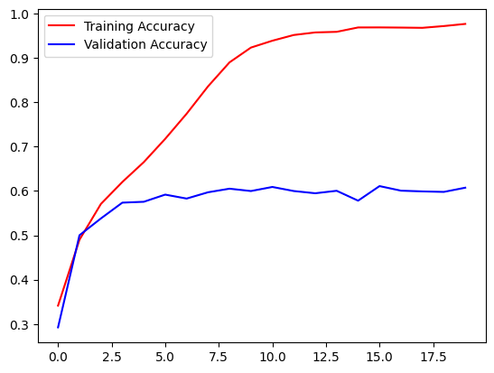

Fig. Training & Validation Accuracy

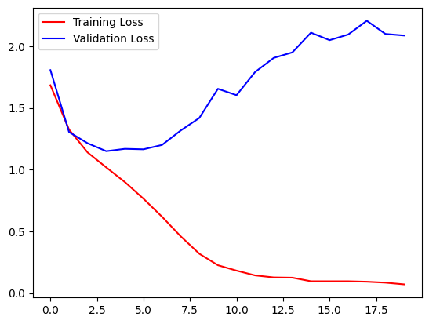

Fig. Training & Validation Loss

**3. Audio Model:**

The CNN-based model for identifying emotions in speech showed remarkable performance throughout training and validation. In terms of identifying emotional states from auditory inputs, the model performs robustly, with training accuracy of 98.89% and validation accuracy of 96.81%. With an accuracy of 96.81%, the model's accuracy on test data further confirms its dependability. This demonstrates the model's capacity to accurately identify emotional cues expressed in speech, offering insightful data for evaluating users' mental health. An important part of the Depression Screening Project is the Audio Model, which provides an approachable and non-intrusive way to identify emotional discomfort.

Evaluation metrics:

* loss: 0.0344
* accuracy: 0.9889
* val_loss: 0.1384
* val_accuracy: 0.9681
* lr: 0.0010

|  |  |  |  |  |
| --- | --- | --- | --- | --- |
| **Emotion** | **Precision** | **Recall** | **F1-Score** | **Support** |
| angry | 0.97 | 0.98 | 0.97 | 1517 |
| disgust | 0.97 | 0.96 | 0.96 | 1575 |
| fear | 0.96 | 0.97 | 0.96 | 1518 |
| happy | 0.96 | 0.96 | 0.96 | 1568 |
| neutral | 0.98 | 0.97 | 0.97 | 1562 |
| sad | 0.97 | 0.97 | 0.97 | 1478 |
| surprise | 0.97 | 0.97 | 0.98 | 512 |
|  |  |  |  |  |
| accuracy |  |  | 0.97 | 9730 |
| macro avg | 0.97 | 0.97 | 0.97 | 9730 |
| weighted avg | 0.97 | 0.97 | 0.97 | 9730 |

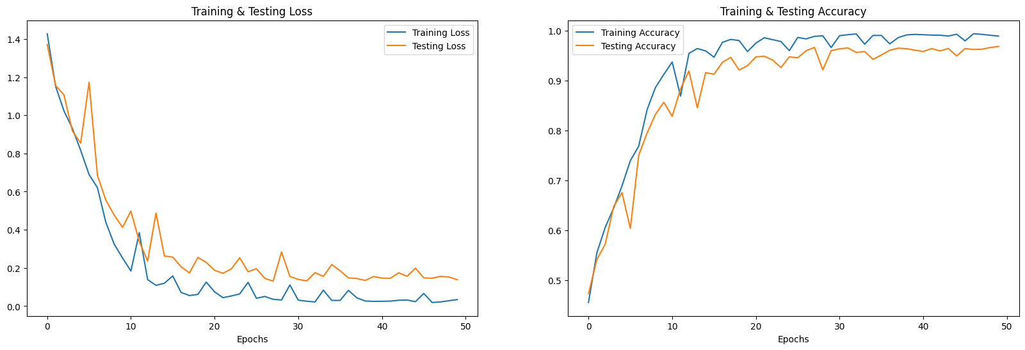

Fig. Training & Testing Loss & Accurancy

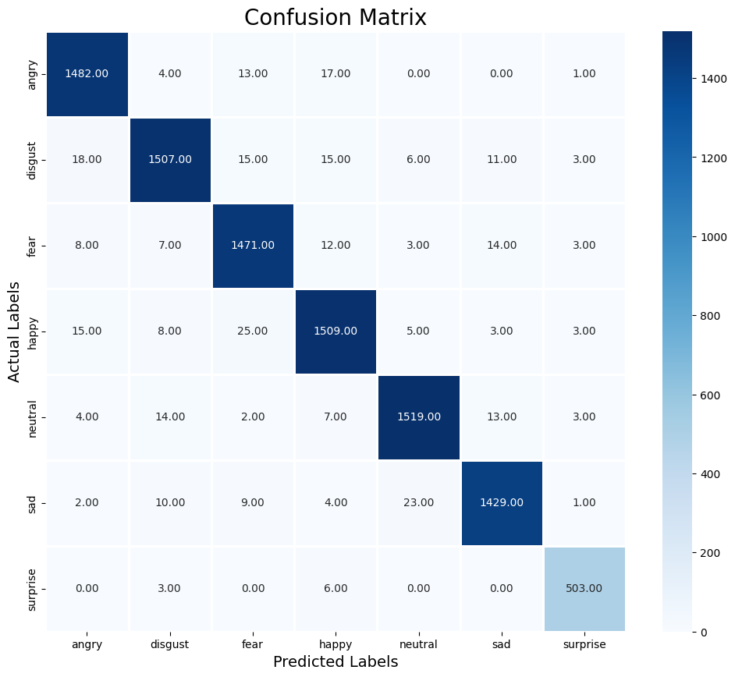

Fig. Confusion Matrix (Actual & Predicted Labels)

**Discussion:**

The three models' respective results demonstrate the variety of methods used by the Depression Screening Project to evaluate users' mental health in a comprehensive manner. The Question Model performed better than the Video and Audio Models in terms of correctly identifying depression based on user responses. The Video Model's mediocre performance indicates that more refinement and investigation of cutting-edge methods are required to improve the precision of facial emotion recognition. On the other hand, the Audio Model performed admirably, suggesting that it has the potential to be a trustworthy instrument for identifying emotional distress in speech inputs.

Additionally, the integration of multiple screening modalities, including questionnaire-based assessments, facial emotion recognition, and speech emotion recognition, underscores the project's commitment to providing users with a holistic and nuanced understanding of their mental health. By leveraging a combination of traditional methodologies and cutting-edge technologies, the Depression Screening Project aims to empower individuals to take proactive steps towards self-care and treatment. Furthermore, ongoing refinement and optimization of the screening models will be essential to enhance accuracy, reliability, and accessibility, ultimately advancing the project's goal of promoting mental health awareness and support.